Patterns of thought:
Decomposition of whole brain connectivity and self-reported experience reveal neuro-cognitive phenotypes that predict cognitive function.

Hao-Ting Wang¹, Danilo Bzdok ^{2,3,4}, Daniel Margulies⁵, Cameron Craddock⁶, Michael Milham⁶, Elizabeth Jefferies ¹ & Jonathan Smallwood¹ .
¹ Department of Psychology, The University of York, Heslington, York, England.
² Department of Psychiatry, Psychotherapy and Psychosomatics, RWTH Aachen University, Germany.
³JARA-BRAIN, Jülich-Aachen Research Alliance, Germany
⁴Parietal team, INRIA, Neurospin, bat 145, CEA Saclay, 91191 Gif-sur-Yvette, France
⁵ Neuroanatomy and Connectivity Group, Max Plank Institute for Cognition and Brain Sciences, Leipzig, Germany.
⁶ Center for Biomedical Imaging and Neuromodulation, Nathan S. Kline Institute for Psychiatric Research, New York State Office of Mental Health

Address for correspondence:
Hao-Ting Wang, Department of Psychology, The University of York, Heslington, York, England, UK.

Email: haoting.wang@york.ac.uk

Acknowledgements
EJ was supported by BBSRC (BB/J006963/1) and ERC (SEMBIND - 283530). JS was supported by ERC (WANDERINGMINDS - 646927), Volkswagen Foundation (Wandering Minds - 89440 and 89439) and the John Templeton Foundation, “Prospective Psychology Stage 2: A Research Competition”. DB was supported by the German Research Foundation (DFG, BZ2/2-1, BZ2/3-1, and BZ2/4-1), International Research Training Group (IRTG2150), Amazon AWS Research Grant (2016 and 2017), the German National Academic Foundation, and the START-Program of the Faculty of Medicine, RWTH Aachen University.

Abstract
Converging evidence from psychology and neuroscience suggests that variation in unconstrained neurocognitive activity has implications in a wide range of domains. The current study used a novel approach to identify this variation by using machine learning to simultaneously decompose self-report measures of experience with patterns of intrinsic neural function. We found stable, whole-brain, neurocognitive patterns with positive and negative relationships to cognitive function. Neurocognitive patterns of unconstrained cognition, linked to better performance, emphasised similarities in the behaviour of the default and fronto-parietal networks; both were decoupled from primary and attention networks. In contrast, patterns of reduced connectivity between these networks was linked to worse control and lower intelligence. Together these patterns suggest that better cognitive function emerges when default and fronto-parietal networks behave in a similar fashion, while dysregulation of this axis was linked to less effective cognitive performance. Finally, our data shows that similar patterns of self-reports, can have different associated neural patterns, and have opposing links to cognitive function demonstrating that experiential reports can relate to connectome wide patterns of connectivity, and meaningful behaviour, in multiple ways. This observation emphasises the need to adopt a multi method, multi variate approach when exploring the neural correlates of experience.

Introduction
The scope of human mental life is not limited to events in the here and now, the experience of mind-wandering illustrates how often we imagine people, places and events beyond those in our immediate environment (Smallwood and Schooler 2015). Psychological studies show that thoughts unrelated to the here-and-now make up a substantial element of daily life (Killingsworth and Gilbert 2010) and are linked to well-being, intelligence and creativity (Mooneyham and Schooler 2013, Smallwood and Schooler 2015). In neuroscience, metrics defined from the brain at rest describe how neural function is organised (Glasser, Coalson et al. 2016, Margulies, Ghosh et al. 2016). They also reflect individual differences in cognitive function, e.g. (Finn, Shen et al. 2015), psychiatric conditions (Nooner, Colcombe et al. 2012) and demographic and lifestyle factors (Smith, Nichols et al. 2015). These findings establish unconstrained neurocognitive processing as a core element of cognition, highlighting the need to formally understand its contribution to adaptive functioning.
At the core of this question is understanding how and why unconstrained neurocognitive processes relate to patterns of functional outcomes in the manner that they do (Smallwood 2013). Studies of spontaneous thought have revealed opposing relationships with measures of executive control (McVay and Kane 2009, Baird, Smallwood et al. 2011, Levinson, Smallwood et al. 2012, Mrazek, Smallwood et al. 2012, Rummel and Boywitt 2014) and creativity (Baird, Smallwood et al. 2012, Ruby, Smallwood et al. 2013, Smeekens and Kane 2016). These contradictory patterns may emerge because unconstrained neural activity is heterogeneous, containing multiple states that differ in their experiential content, temporal dynamics and/or their underlying neurocognitive architecture (Christoff, Irving, Fox, Spreng, & Andrews-Hanna, 2016; Smallwood & Andrews-Hanna, 2013). This proposal intuitively addresses why unconstrained processing has a complex pattern of functional outcomes, since similar patterns of thinking could relate to different patterns of neural activity or functional outcomes in different ways. However, it places at a premium the ability to be able determine these unique patterns of variation.
In the current study, we adopted a novel approach to determine the underlying structure of patterns of variation linked to unconstrained thought. We used a large publicly available data set that contained measures of resting-state functional magnetic resonance imaging (fMRI), and an accompanying self-report measure describing cognition experienced during the resting state (Nooner, Colcombe et al. 2012, Gorgolewski, Lurie et al. 2014). We applied machine learning techniques to combine matrices of self-reports of spontaneous cognition, with matrices of whole brain connectivity data. This analysis produces multivariate patterns common to both connectivity and self-reports, providing dimensions of variation that are mutually constrained by both brain and experience. Moreover, the multivariate nature of the resultant feature space can accommodate complex relationships between patterns of connectivity and self-reports. Our method, therefore, allows us to capture heterogeneous relationships between unconstrained behaviors that would be missed by univariate methods. As a final step we tested whether these neurocognitive dimensions are meaningful by examining if they can predict performance on a battery of available cognitive tasks, including measures of executive control and intelligence.
In our prior work, using a similar approach, we focused on the relationship between connectivity in core nodes of the default mode network at rest, and decomposed these with measures of the content and form that spontaneous thoughts in a subsequent laboratory task recorded on separate days (Wang et al., 2017). This analysis revealed two dimensions with unique relationships to measures of cognitive function: (i) worse performance on complex tasks including fluid intelligence and (ii) better performance on tasks of creativity and generation. In the current study we generalized this method, focusing on experiences that took place during the resting state, and examining patterns of whole brain connectivity, rather than only those within the DMN. We then related these neurocognitive patterns across individuals to identify their unique relationships to an associated battery of measures of cognitive function measures.

Methods

Participant
We analyzed 258 participants (females = 162; age range 18 – 55, M = 34.97, SD = 12.24) were obtained from the enhanced Nathan Kline Institute-Rockland sample (NKI-RS; http://fcon_1000.projects.nitrc.org/indi/enhanced/). Full details of the acquisition of this sample can be found in Nooner et al., 2012. We only include the participants between 18 and 55 years old as our sample, as the assessment of our interests were performed on participants from this age range. All the participants have the MRI data and less than 5 missing data points among the selected assessments. For the details of the selected assessments, please refer to ‘cognitive measures’ session below.
Mind-wandering measure

The New York Cognition Questionnaire (NYC-Q) is a self-report tool used to assess mind-wandering behavior. Specifically, it assesses thoughts and feelings experienced during a specific time. The first section contains 23 questions about the content of thoughts. The questions covered the temporal, social, emotional aspects of spontaneous thoughts. Participants rated each question on a scale of 1 (Completely did not describe my thoughts) to 9 (Completely did describe my thoughts). The second section contains 8 questions about the forms thoughts take, indicating the possible modality involved in the spontaneous thoughts. Participants rated each question on a scale of 1 (Completely did not characterize my experience) to 9 (Completely did characterize my experience). In the current analysis we analyzed the two sections together to provide the comprehensive description of both content form of experience. The full list of the questions and the corresponding labels are presented in Table 1. The questionnaire was administrated once after the resting state scan in order to access the self-generated thoughts emerged during the scanning session. For the full details of the NYC-Q, please refer to Gorgolewski et al., 2014.
Table 1.
The New York Cognition Questionnaire (NYC-Q)
# | Questions | Labels | Average score (z)
Q01 | I thought about things I am currently worried about | Concerns | -1.07
Q02 | I thought about people I have just recently met | People | -0.68
Q03 | I thought of people I have known for a long time (friends) | Friend | 0.63
Q04 | I thought about members of my family | Family | 0.79
Q05 | I thought about an event that took place earlier today | Today - Past | -0.55
Q06 | I thought about an interaction I may possibly have in the future | Social - Future | 0.46
Q07 | I thought about an interaction with somebody that took place in the past | Social - Past | 0.16
Q08 | I thought about something that happened at a place very close to me | Near Location | -1.00
Q09 | I thought about something that made me feel guilty | Guilt | -1.88
Q10 | I thought about an event that may take place later today | Today - Plan | 0.97
Q11 | I thought about something that happened in the recent past (last couple of days but not today) | Recent Past | 0.20
Q12 | I thought about something that happened a long time ago in the past | Distant Past | -1.46
Q13 | I thought about something that made me angry | Anger | -2.12
Q14 | I thought about something that made me happy | Happiness | 0.84
Q15 | I thought about something that made me cheerful | Cheerfulness | 0.78
Q16 | I thought about something that made me calm | Calm | 1.72
Q17 | I thought about something that made me sad | Sadness | -1.82
Q18 | I thought about something that is important to me | Importance | 1.64
Q19 | I thought about something that could still happen today | Today - Future | 1.07
Q20 | I thought about something that may take place in the distant future | Distant Future | 0.39
Q21 | I thought about something that could take place in the near future (days or weeks but not today) | Near Future | 0.77
Q22 | I thought about personal worries | Worries | -0.38
Q23 | I thought about something that happened in a place far away from where I am now | Distant Location | -1.16
Q24 | In the form of images: | Image | 0.63
Q25 | In the form of words: | Words | -0.04
Q26 | Like an inner monologue or audiobook: | Inner Monologue | 0.49
Q27 | Like a television program or film: | Film | -0.04
Q28 | Had a strong and consistent personal narrative: | Narrative | 0.20
Q29 | Had a clear sense of purpose: | Purpose | 1.10
Q30 | Vague and non-specific: | Vagueness | -0.21
Q31 | Fragmented and disjointed: | Fragment | -0.39

Cognitive measures
We selected diverse cognitive measures that were conducted on our targeted age range in the NKI-RS. The selected measures are exacutive control and fluid intellegence, which captured the two primary functional outcome linked to ongoing spontaneous thought as showed by previous literatures (McVay & Kane, 2009; Mrazek et al., 2012). The meaures included the Delis-Kaplan Executive Function System (Swanson, 2005), Wechsler Abbreviated Scale of Intelligence (WASI-II; Wechsler, 1999), and Wechsler Individual Achievement Test – Second Edition Abbreviated (WIAT-IIA; Wechsler, 2005). In D-KEFS we selected tower test (move accuracy ratio), color-word interference test (errors inhibition/switching), verbal fluency test (letter fluency - category fluency), design fluency test (design accuracy), trail making test (sequencing errors score + set-loss errors score + time-discontinue errors score), and proverb test (Swanson, 2005). For the ease of interpretation, we used the rescaled score (M = 10, SD = 3) provided in the data set in our analysis. Tasks measuring error rate (color-word interference test and trail making test) were reversed, therefore high rescaled scores indicated always good task performance.

MR data processing
Resting-state fMRI. We used resting-state fMRI to leverage the relationship between the general functional organisation of the brain on the behavioural measures. Among the resting state scans provided by the NKI-RS, we selected R-mfMRI (TR = 1400msec; voxel size = 2mm isotropic; duration = 10 minutes) for our analysis. Functional and structural data were pre-processed using Configurable Pipeline for the Analysis of Connectomes (C-PAC; https://fcp-indi.github.io/) to interface with FMRIB’s Software Library (FSL version 5.0, www.fmrib.ox.ac.uk/fsl). Individual FLAIR and T1 weighted structural brain images were extracted using Brain Extraction Tool (BET). Structural images were linearly registered to the MNI-152 template using FMRIB's Linear Image Registration Tool (FLIRT). The resting state functional data were pre-processed and analyzed using the FMRI Expert Analysis Tool (FEAT). X, Y, Z displacement and the three axis rotations were used to calculate the mean frame displacement (FD), characterising movement of each participant during the scanning session (Power et al., 2014). These estimates were later used at the group-level to account for subject specific head motion. No global signal regression was applied. The individual subject analysis involved: motion correction using MCFLIRT; slice-timing correction using Fourier space time-series phase-shifting; spatial smoothing using a Gaussian kernel of FWHM 6 mm; bandpass filtering (0.1 Hz < f < 0.009 Hz); six motion parameters (as estimated by MCFLIRT) regressed out; cerebrospinal fluid and white matter signal regressed out (top five PCA components, CompCor method).
Connectivity matrices. To describe the functional architecture of the whole brain, we transformed the resting state BOLD time series into connection strength values of the different networks for each participant. The whole brain parcelation was obtained from connectivity-based functional parcellation created by Yeo and collegues (Yeo et al., 2011). The 7 network parcellation was used in the current study. First, we extracted and then averaged the time series of all voxels within the masks of the given network. Second, we created $7× 7$ symmetrical correlation matrices representing the correlations of the network signal that was computed for all the individual subjects. The off-diagonal of each correlation matrix contained 21 unique network-network connection strengths. This approach provided a measure of connection strength of the network-network coupling of the whole brain for each participant.

Conjoint decomposition of functional connectomes and mind-wandering measures
We performed a sparse canonical correlation analysis (SCCA; see Hastie, Tibshirani, & Wainwright, 2015) on the functional connectomes and the NYC-Q reports, to yield latent components that simultaneously described neural organization and experience (For similar application, see Wang et al., 2017). SCCA optimised the linear correlation between the low-rank projections of two sets of multivatiate data sets with sparse model to regularise the decomposition solutions due to our interests in the increasing interpretability. The regularization function of choice is L₁ penalty, therefore it produces ‘sparse’ coefficients, meaning that the correlation coefficent matrics will contain a maximum of exactly zero coefficents. A reliable and robust open-source implementation of the SCCA method was retrieved as R package from CRAN (PMA, penalized multivariate analysis, version 1.0.9; Wang et al., 2017; Witten, Tibshirani, & Hastie, 2009). The values of L₁ penalty for the functional connectomes and the NYC-Q reports were chosed by cross-validation suggested by previous studies (Smith et al., 2015; Witten et al., 2009). The procedure is described in the section below.

Parameter and model selection

We first determine the number of latent component in the potential model by running a preliminary analysis with no sparsity and calculated the explained variances for the two datasets. Having 4 components in the model will account for 78% and 29% of the variance respectively for the connection strength and self reports on thoughts. In the next procedure, we would search the values of L₁ penalty with the best model performance with 4 latent components.
We employed cross-validation (CV) to select the most generalisable model across population samples. The values of L₁ penalty for the functional connectomes and the NYC-Q reports were chosed by a K-fold CV, where the penalty values were chosen using a grid search to maximise the quality of CV objective metrice. The objective metrice of choice was cumulative explained variances. The explained variance of each latent compoent was calculated using the squared canonical correlation. A squared canonical correlation is the amount of variance in one data set explained by the other dataset’s variate. High explained variance suggests a high ability to predict between the two data set. As the aim of employing a spares model is increase intepretibility, we confined the parameter search range to prevent extremely sparsed and non-sparsed result. We searched for the best L₁ penalty values between 0.3 and 0.9 in 0.1 increment, which resulted in 49 set of paramters. We decided to use 20% of the sample as the outer testing set and 5 folds for the inner training process. Each fold will have around 40 participants.
For each set of candidate values, we first splited 20% of the shuffled original data to a test set that was held-out for the CV process, and the rest of the data was separated into 5 consecutive folds with shuffling. We train the model on the 4 subsets and computed the cumulative explained variances on the last subest. This procedure continues untill all the folds has been tested once. We then average the objective metrices against each of the folds and then finalised the model of the current parameters. After that we train the model using the selected parameters against all five folds and test it against the hold-out test set to obtain the out-of-sample model cumulative explained variances. We selected the final parameter set with the best out-of-sample model cumulative explained variances. This set of parameter was later trained on the whole population, and the number of component in the final model was determined here by the model’s explained variace on the two dataset respectively. we used the canonical variates of it to compute the latent component loadings. There are two sets of canonical weights in a latent compoent, and the a weighted sum of variables forms the canonical variate. For each latent compoennt, we averaged the z-score of the canonical variates of the connection strength and NYC-Q as the latent compoent loadings. These loadings described the summary of the experience with both the neural basis and the content reports. The canonical vectors obtained from this final model were used in the subsequent group analysis. The parameter grid search and k-fold CV was conducted by the implementation in a Python library scikit-learn (http://scikit-learn.org/stable/, version 0.18.2). The detailed algorithm for selecting the penalty values are presented in Appendex A.

Group analysis
To determine how the patterns of experience revealed by SCCA are predicting the performance on fluid intellegence and exacutive function tests, we used type III Multivariate Analysis of Variance (MANOVA) with Pillai’s trace test . This test is considered to be the most powerful and robust statistic for general use (Huberty & Olejnik, 2005). The analysis was conducted in R (version 3.3.1) using function ‘Manova’ in R package ‘car’ (companion to applied regression, version 2.1-5). The measures of cognitive performance were the dependent variables and the individual loadings for each of the latent components describing experience from the SCCA as well as age and head motion indicated by Jenkinson’s mean FD (Jenkinson, Bannister, Brady, & Smith, 2002) were the independent variables.

Results
Determining consistent categories of experience
We used SCCA to determine connectome wide dimensions that describe common variance shared by descriptions of brain and experience. This took as input individual scores for the connections between each of the Yeo networks (see Fig S1, Top Panel) and the loadings of each item of the New York Cognition Questionnaire (NYC-Q, see Fig S1, Lower Panel). We applied SCCA with 5-fold CV and accepted the model of 4 canonical components with penalty levels of 0.7 on the functional connectivity and 0.3 on the NYC-Q that indicated the best out-of-sample prediction on our data (see Methods). The latent components yielded by the best model are presented in Fig 1. The heat maps describe the node-to-node correlations while the word clouds describe the loadings on the self-report items.
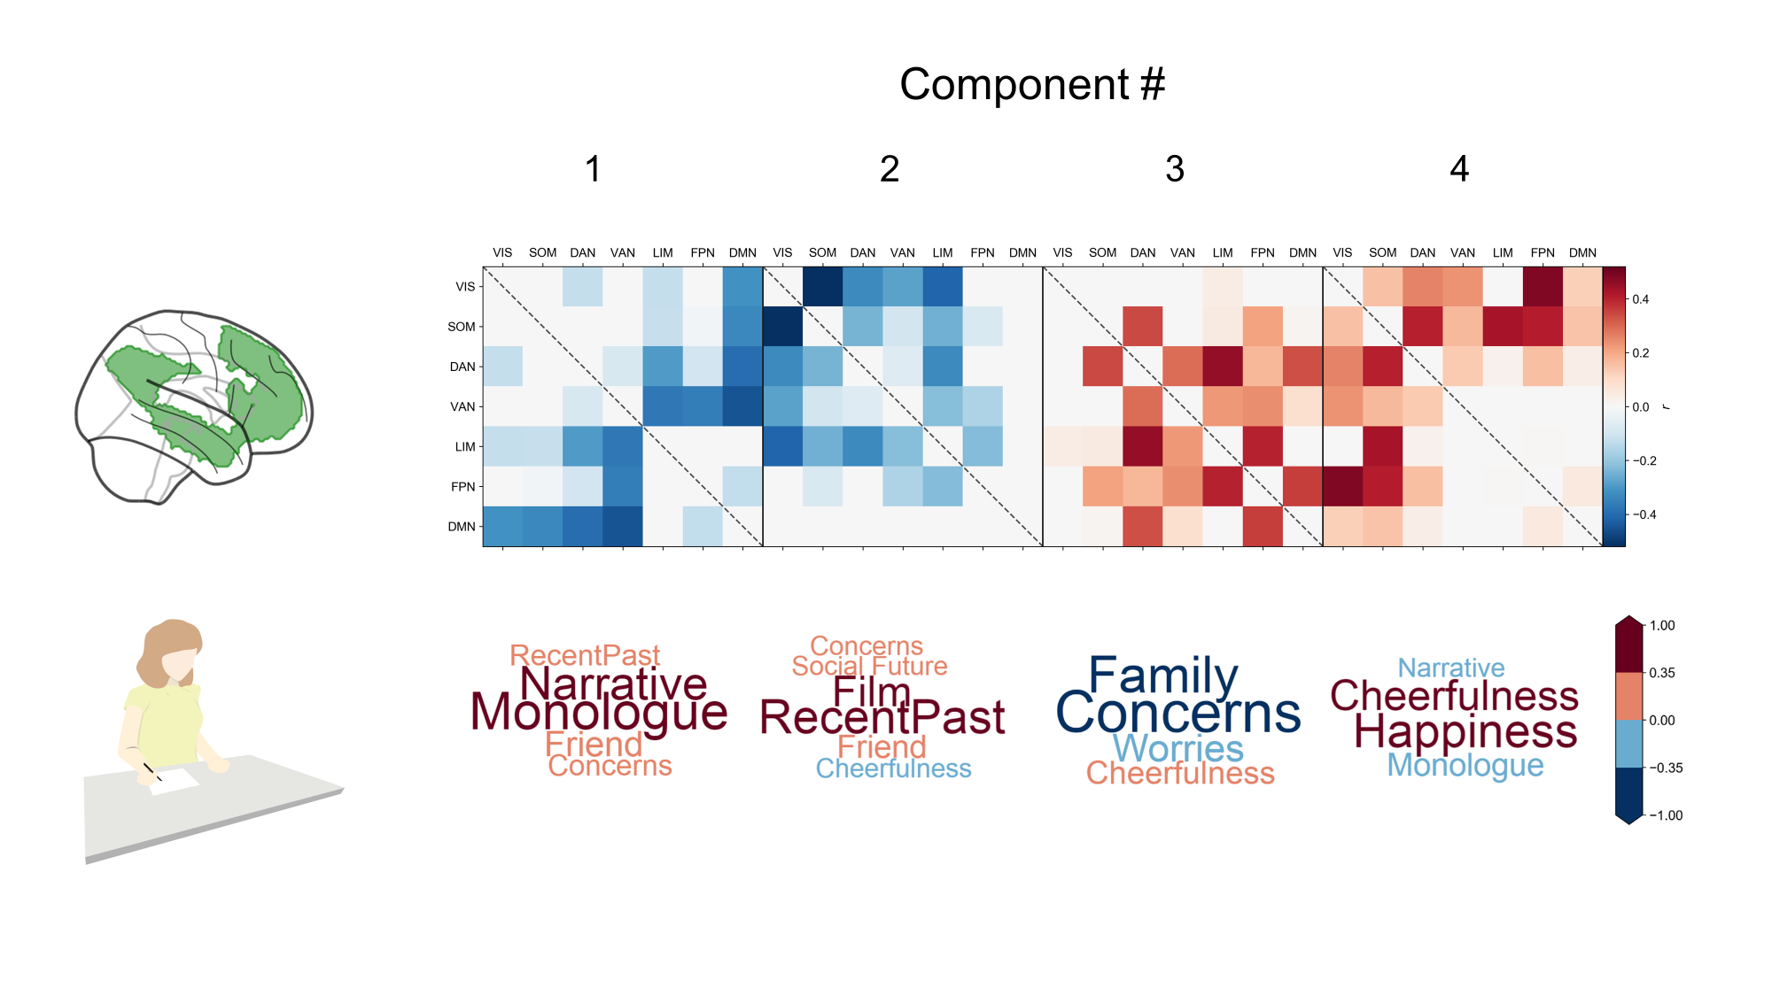
Figure 1. Unique neurocognitive dimensions revealed by sparse canonical correlation analysis of measures of whole brain connectivity and self-reported descriptions of ongoing experience. The heat map describes the node-to-node connectivity between different Yeo networks. The word clouds reflect the loading on the relevant self-report items.
The first component, is dominated by the somatomotor network and ventral attention network. These are dissociated from the transmodal networks (limbic, default and fronto-parietal). The somatomotor network is also less correlated to visual cortex. The limbic system dissociates from the attention systems. The patterns of self-reports reflect themes of verbally mediated thought (“narrative” and “monologue”) as well as content with both social (“family”, and “friends”) and temporal aspects (“distant future” and “recent past”). The second component, is dominated by the dorsal attention and visual networks. These are both dissociated from ventral attention, frontoparietal and default mode networks. The ventral attention network dissociates from somatomotor. The pattern of self reports emphasise verbal themes (high loadings on “narrative” and “monologue”) as well as absence of imagined scenes (low loadings on “distant locations” and “near locations”) or deliberate intention (low loadings on “purpose”). The third component is dominated by the fronto-parietal and limbic networks, which show reduced correlation with each other, as well as other regions of cortex. Limbic connectivity was reduced with visual and dorsal attention networks. Connectivity was also reduced between the fronto parietal network and somato motor and the default mode networks. There was also reduced communication between the attention networks. The self reports reflects themes of verbal (high loadings on “narrative” and “inner monologue”), social (high loadings on “family” and “friends”) and were detail (low loading on “vague”). Finally, the fourth component is dominated by decoupling between the visual system and all networks except the fronto-parietal and the default mode network. The dorsal attention network has decreased connectivity with somatomotor and ventral attention systems. The self-reports for this component emphasise thoughts with a retrospective temporal focus (high loadings on “social past” and “recent past”), social content (high loadings on “friends” and “social past”) and visual imagery (high loadings on “film” and “images”).

A different way to visualise the four neuro cognitive components is by examining their common and distinct features. We calculated the number of times a node was selected by squaring the loading for each component and summating binarized versions of the transformed matrices. This revealed that the connection between the VAN and DAN (Components 2, 3 and 4) and the FPN-SOM Components (1, 3 and 4) were the most common nodes, occuring in Components 2, 3 and 4. The connection between the Limbic and Default mode networks was the least frequent, occuring in none of the selected components. A comparable analysis of the self-report information revealed that the term “narrative” was present in all components, while the terms “film”, “friend”, and “inner monologue” were present in Components 1, 2 and 3.

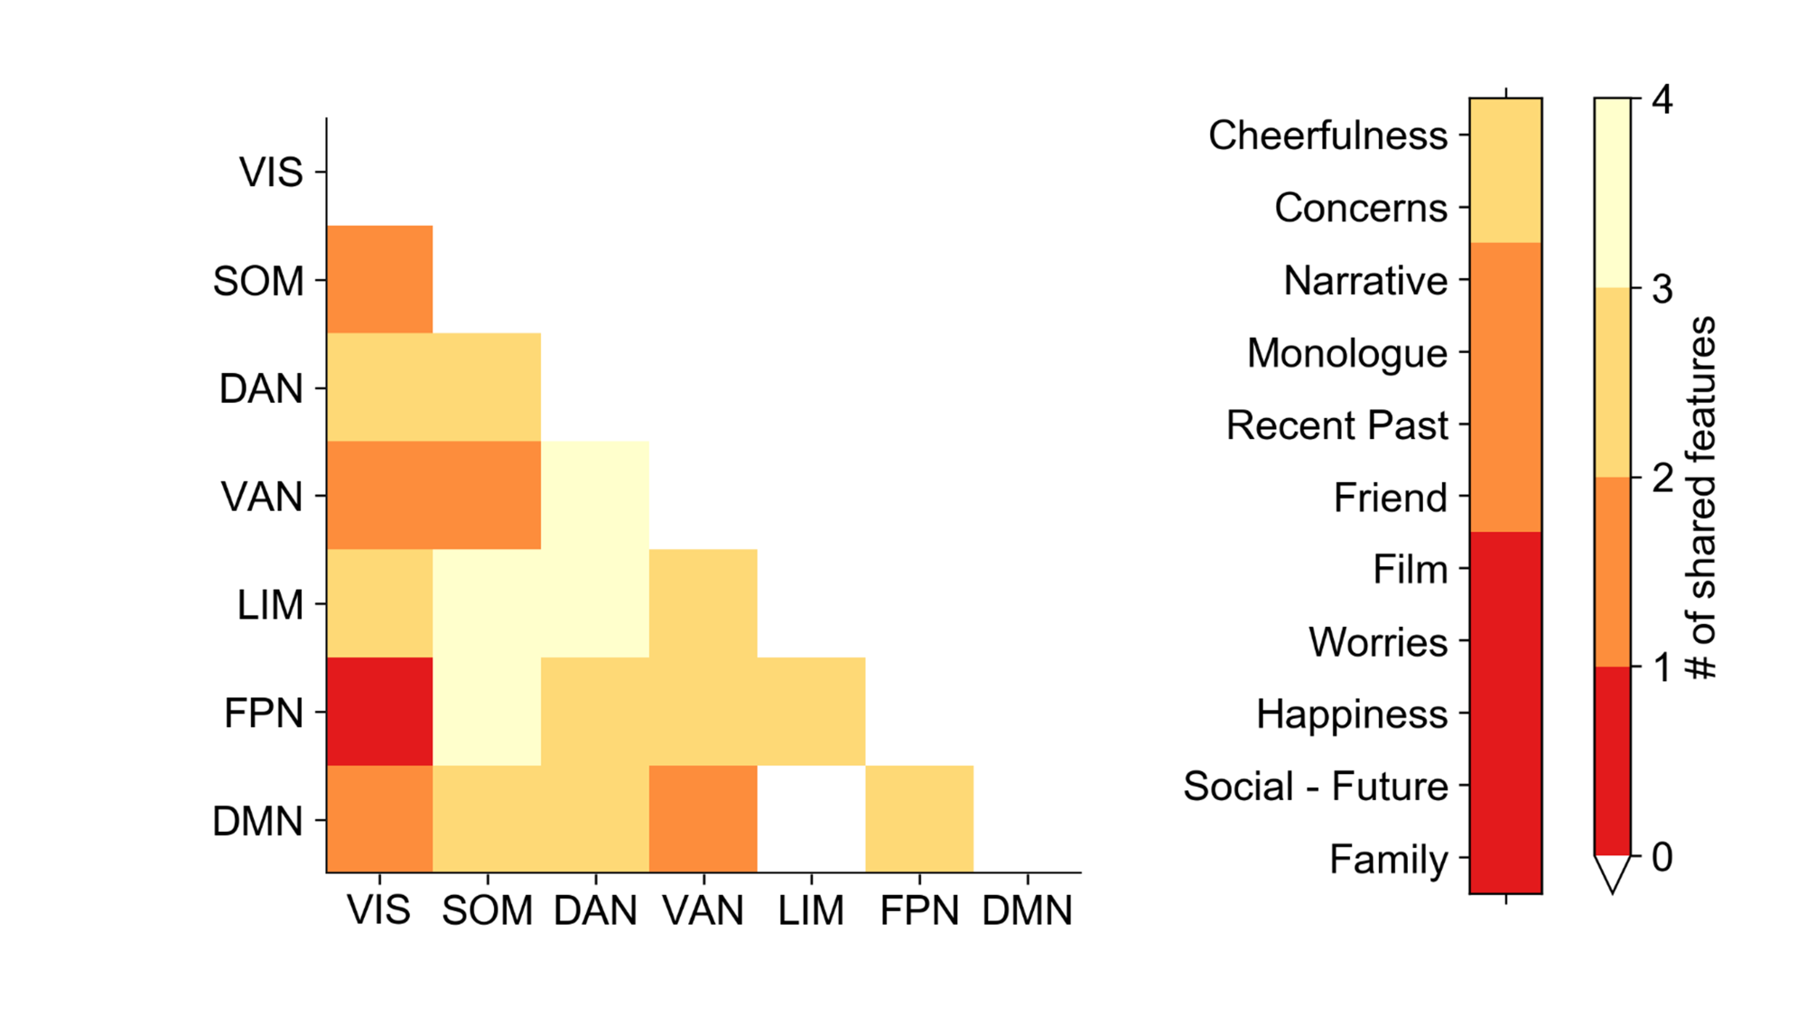

Figure 2. Left. Comparison of the total number of connectivity features across the four selected component. The highest node was the VAN-DAN and the FPN-SOM (3) and the lowest was limbic – default (0). Right. Comparison of the total number of self-report features. The “Narrative” item was the most frequent, selected in each component.
The relationship between neuro-cognitive components and cognitive function assessed in the laboratory
Having documented four reliable neurocognitive dimensions, we next examined if they explained unique patterns of expertise in our battery of cognitive tasks. We used Multivariate Analysis of Variance (MANOVA) in which cognitive performance on the battery of selected tasks was the dependent variables and the individual loadings for each of the canonical components describing experience from the SCCA, as well as age and head motion, were the independent variables. Three of the four canonical components described significant variance in our battery of tasks at multivariate level: Component 1 (F(8, 244) = 4.51, p < .001, η²_{p} = .129), Component 2 (F(8, 244) = 1.20, p < .05, η²_{p} = .061). In the univariate level, color-word interference test was significantly explained by Component 1 (F(1, 252) = 7.48, p = .007, η²_{p} =0.029); the design fluency task was significantly explained by Component 1 (F(1, 252) = 7.01, p = .009, η²_{p} =0.027); the proverb test was significantly explained by Component 1 and 2(F(1, 252) = 27.17, p < .001, η²_{p} =0.098; F(1, 252) = 6.70, p = .010, η²_{p} =0.026); the WASI score was significantly explained by Component 1 (F(1, 252) = 12.99, p < .001, η²_{p} =0.049); the WIAT score was significantly explained by Component 1 (F(1, 252) = 11.96, p < .001, η²_{p} =0.045). None of the nuisance variables were significant predictors of cognitive performance, either at the uni-variate, or at the multi-variate level. The relationships between the neurocognitive dimensions and the pattern of relationships on the cognitive battery are summarized in the parameter estimates table in the form of a heat map in Figure 3.
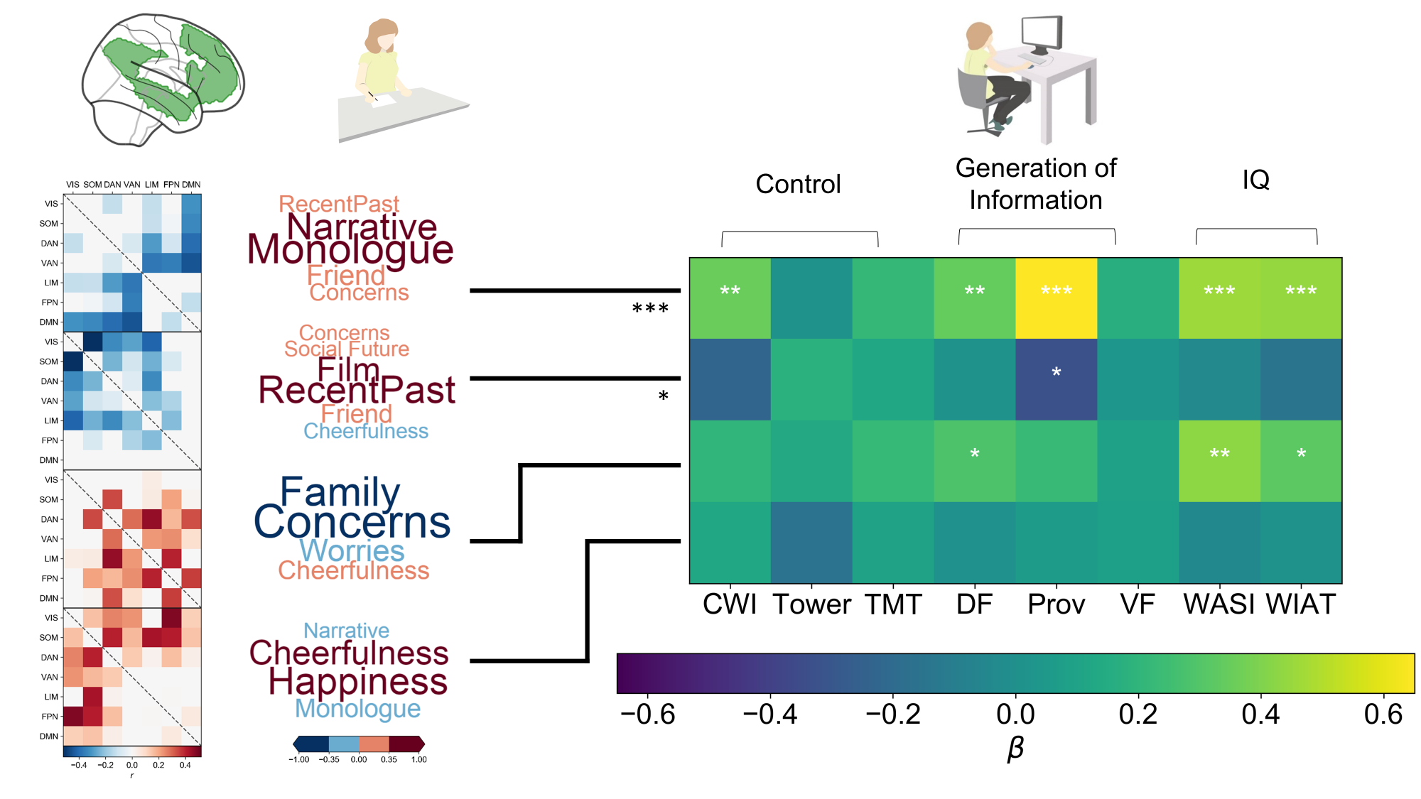
Figure 3. The relationship between the different neural-cognitive components and the measures assessed in the cognitive battery. The components 1 and 2 were significant at the multivariate level. The cells with asterisk(s) indicates the significant parameter estimates for each variable. Significant codes: 0 ‘***’ 0.001 ‘**’ 0.01 ‘*’. CWI – Colour word interference, DF – Design fluency, Pro- Proverbs, TOW – Tower of London, TMT – Trail making task, VF- Verbal Fluency, WASI – Wechseler Adult Intelligence Test, WIAT – Weschler Individual Attainment Test. Nuisance variables are not reported here as none of them were significant predictors of cognitive performance.
Component one, was linked to good inhibition in color-word interference test (β = 0.351, t(251) = 2.74, p = .007, 95% CI [0.10 0.60]), patterns which indicate better cognitive control. It also showed a positive correlation with spatial construction in design fluency (β = 0.344, t(251) = 2.65, p = .009, 95% CI [0.09 0.60])and novel verbal abstractions in proverb test (β = 0.650, t(251) = 5.21, p < .001, 95% CI [0.40 0.90]). These patterns suggest well developed capabilities at generating novel task relevant in an appropriate manner. Finally, this component was associated with greater intelligence as measured by WASI-II (β = 0.457, t(251) = 3.61, p < .001, 95% CI [0.20 0.71]) and WIAT (β = 0.443, t(251) = 3.56, p < .001, 95% CI [0.19 0.70]). Component one, therefore, corresponds to a pattern of relatively high cognitive functioning across the domains assessed in our study. Component two show a negative correlation with the performance on proverb test (β = -0.330, t(251) = -2.59, p = .010, 95% CI [-0.58 -0.08]), which was linked to poor performance with the strongest impact on the ability to make novel abstractions in the verbal domain.

Discussion

We set out to identify neurocognitive patterns derived through the simultaneous decomposition of whole brain connectivity data, with self-reports of experience. We found four stable canonical components, describing unique dimensions of neural-experiential variation. Three of these four components described independent, multivariate patterns in a battery of cognitive measures. This establishes the validity of these neurocognitive components since they capture variance related to important aspects of cognitive function, such as the WAIS. Our analysis, also recapitulated a pattern of functional associations similar to that seen in our previous study (Wang et al., in press). In that analysis we found two canonical components: (i) linked to deficits on measures of executive control and intelligence, and (ii) linked to better performance on tasks involving generativity (such as fluency and creativity). These behavioral patterns broadly correspond to those associated with Components 1 and Component 3 observed in the current dataset. Parallels also exist at the experiential level: Self-reports loadings on positive and vivid were present in the poor executive component in our prior study. These may correspond to the low loadings on “guilt” and “vague” seen in Component 3. It is important to note, however, that the specific battery of questions and tasks used in the two studies are different, limiting the capacity to draw highly specific conclusions across the studies. Nonetheless the behavioral commonality is sufficiently overlapping across both studies to be optimistic about the generalizability of the results of both experiments. Having established the validity and reliability of our results, we next consider their implications for neurocognitive accounts of attentional lapses, perspectives on how the topographical organization of the cortex constrains cognition, and their implications for future studies of unconstrained neurocognitive processing.

First, our results suggest that the variation in unconstrained cognition linked to poor cognitive function may emerge from dysregulation between the default mode and fronto-parietal networks. Component 3, for example, had negative associations with measures of control and intelligence - hallmark features of the pattern of executive failure linked to mind-wandering (McVay and Kane 2009, Mrazek, Smallwood et al. 2012, Mooneyham and Schooler 2013). It was also dominated by reduced connectivity between the fronto-parietal with other networks, including the default mode. Reduced integration between the default mode network and the fronto parietal network, ws not present in components in which unconstrained processing is linked to positive intellectual outcomes. For example, in both Components 1 and 2, the default mode network and the fronto-parietal network show similar patterns of decoupling from primary or attention networks. These components were linked to better, rather than worse performance, suggesting that high levels of cognitive function are preserved when these two networks maintain a normal level of integration and operate in a coordinated manner with respect to other networks. Moving forward, our data suggests that the negative consequences of unconstrained cognition on intellectual function emerge when the default mode network and the executive control network do not behave in a coordinated manner. This view is consistent with executive-failure accounts of the links between mind-wandering and error (McVay and Kane 2010) and suggests that dysregulation between the DMN and FPN at rest may act as a potential biomarker for examining treatments designed to alleviate attentional problems linked to inattention, such as mindfulness (Mrazek, Franklin et al. 2013).

Second, our analysis highlights the functional significance of uni-modal and transmodal regions. It has been hypothesized that the functional difference between unimodal and transmodal regions of cortex reflects their proximity from input / output systems (Mesulam 1998, Buckner and Krienen 2013, Margulies, Ghosh et al. 2016). Unimodal regions are located proximal to systems that govern perception and action and consequently their functions remained closely tethered to acting on the external world. In contrast, transmodal association areas, such as the fronto-parietal and default mode networks, are distant in both functional and structural terms from input / output systems (Margulies, Ghosh et al. 2016). It has been suggested that this functional distance reflects a mechanism that allows information processing in these regions to be relatively abstract (Mesulam 1998). Remarkably, our decomposition of resting state data using self-reported information as a dimension of interest supports this perspective. Component 1 was linked to greater functional decoupling between transmodal regions (i.e. the fronto-parietal and default mode networks) with somato-motor and ventral attention networks, while Component 2 was linked to greater functional decoupling between the same transmodal regions with visual and dorsal attention networks. Both components emphasized self-reports of an “inner monologue” and “a strong personal narrative” and both were linked to better rather than worse intellectual performance (see Fig 3). Our results, therefore, provide quantitative evidence that intelligent behavior can emerge when transmodal and unimodal regions of cortex are decoupled at rest. In this way these data provide an independent empirical grounding for the hypothesis that the functional decoupling made possible by the topographical organization of the cortex is a mechanism that allows for more adaptive unconstrained states to emerge (Mesulam 1998, Buckner and Krienen 2013, Margulies, Ghosh et al. 2016).

Third, the components identified in our analysis highlighted components that were broadly similar in the patterns of self-reported experience. For example, terms like “narrative”, ”film”, “friend” and “monologue” was a characteristic of three of the four components. Despite this similarity, the components were clearly differentiable in terms of their patterns of connectivity, and perhaps most importantly, in their associated behavioral outcomes. These data demonstrate that self-reported information can relate to connectome wide patterns of connectivity and behavioral outcomes in more than one meaningful way. This suggests that self-reports may have the property of degeneracy, since at face value their descriptions suggest greater similarity than is apparent at either the neural or cognitive level. We conclude that univariate treatments of experience sampling data can obscure relationships that would be apparent if the data was analyzed in a multivariate fashion. Theoretically, the apparent degeneracy of the self-reported information, may be a contributory factor to the many contradictory relationship between individual differences and spontaneous thought (e.g. (McVay and Kane 2009, Levinson, Smallwood et al. 2012). Moving forward, it is likely to be important to adopt a multivariate approach to the examination of spontaneous thought. Ideally future studies could use techniques that either seek patterns of based on the covariance structure of the self-reported data (Ruby, Smallwood et al. 2013, Ruby, Smallwood et al. 2013, Smallwood, Karapanagiotidis et al. 2016), or by exploiting the co-variation structure associated with objective measures to refine the decomposition approach as we did. Note that the combination with objective measures does not require neural data, mind-wandering has been linked to a host of different covert measures including response time (Franklin, Mrazek et al. 2017), event related potentials (Smallwood, Beach et al. 2008), heart rate (Smallwood, O'Connor et al. 2007) and pupil dilation (Konishi, Brown et al. 2017).

References
Christoff, K., Irving, Z. C., Fox, K. C. R., Spreng, R. N., & Andrews-Hanna, J. R. (2016). Mind-wandering as spontaneous thought: a dynamic framework. Nature Reviews Neuroscience, 17(11), 718–731. http://doi.org/10.1038/nrn.2016.113
Gorgolewski, K. J., Lurie, D., Urchs, S., Kipping, J. A., Craddock, R. C., Milham, M. P., … Smallwood, J. (2014). A correspondence between individual differences in the brain’s intrinsic functional architecture and the content and form of self-generated thoughts. PLoS ONE, 9(5). http://doi.org/10.1371/journal.pone.0097176
Hastie, T., Tibshirani, R., & Wainwright, M. (2015). Statistical Learning with Sparsity: The Lasso and Generalizations. CRC Press. http://doi.org/10.1201/b18401-1
Huberty, C. J., & Olejnik, S. (2005). Applied MANOVA and Discriminant Analysis. Applied MANOVA and Discriminant Analysis. http://doi.org/10.1002/047178947X
Jenkinson, M., Bannister, P., Brady, M., & Smith, S. (2002). Improved optimization for the robust and accurate linear registration and motion correction of brain images. NeuroImage, 17(2), 825–841. http://doi.org/10.1016/S1053-8119(02)91132-8
McVay, J. C., & Kane, M. J. (2009). Conducting the train of thought: Working memory capacity, goal neglect, and mind wandering in an executive-control task. Journal of Experimental Psychology. Learning, Memory, and Cognition, 35(1), 196–204. http://doi.org/10.1037/a0014104
Mrazek, M. D., Smallwood, J., Franklin, M. S., Chin, J. M., Baird, B., & Schooler, J. W. (2012). The role of mind-wandering in measurements of general aptitude. Journal of Experimental Psychology: General, 141(4), 788–798. http://doi.org/10.1037/a0027968
Nooner, K. B., Colcombe, S. J., Tobe, R. H., Mennes, M., Benedict, M. M., Moreno, A. L., … Milham, M. P. (2012). The NKI-Rockland sample: A model for accelerating the pace of discovery science in psychiatry. Frontiers in Neuroscience, 6(OCT), 152. http://doi.org/10.3389/fnins.2012.00152
Power, J. D., Mitra, A., Laumann, T. O., Snyder, A. Z., Schlaggar, B. L., & Petersen, S. E. (2014). Methods to detect, characterize, and remove motion artifact in resting state fMRI. NeuroImage, 84, 320–341. http://doi.org/10.1016/j.neuroimage.2013.08.048
Smallwood, J., & Andrews-Hanna, J. (2013). Not all minds that wander are lost: The importance of a balanced perspective on the mind-wandering state. Frontiers in Psychology, 4, 441. http://doi.org/10.3389/fpsyg.2013.00441
Smith, S. M., Nichols, T. E., Vidaurre, D., Winkler, A. M., Behrens, T. E. J., Glasser, M. F., … Miller, K. L. (2015). A positive-negative mode of population covariation links brain connectivity, demographics and behavior. Nature Neuroscience, (September), 1–7. http://doi.org/10.1038/nn.4125
Swanson, J. (2005). The Delis-Kaplan Executive Function System: A Review. Canadian Journal of School Psychology, 20(1–2), 117–128. http://doi.org/10.1177/0829573506295469
Wang, H.-T., Poerio, G. L., Murphy, C. E., Bzdok, D., Jefferies, E., & Smallwood, J. (2017). Dimensions of Experience: Exploring the Ontology of the Wandering Mind. Psychological Science.
Wechsler, D. (1999). Wechsler Abbreviated Scale of Intelligence. San Antonio, TX: The Psychological Corporation.
Wechsler, D. (2005). Wechsler Individual Achievement Test 2nd Edition (WIAT II). London: The Psychological Corporation.
Witten, D. M., Tibshirani, R., & Hastie, T. (2009). A penalized matrix decomposition, with applications to sparse principal components and canonical correlation analysis. Biostatistics, 10(3), 515–534. http://doi.org/10.1093/biostatistics/kxp008
Yeo, B. T. T., Krienen, F. M., Sepulcre, J., Sabuncu, M. R., Lashkari, D., Hollinshead, M., … Buckner, R. L. (2011). The organization of the human cerebral cortex estimated by intrinsic functional connectivity. J Neurophysiol, 106(3), 1125–1165. http://doi.org/10.1152/jn.00338.2011
References
Baird, B., J. Smallwood, M. D. Mrazek, J. W. Kam, M. S. Franklin and J. W. Schooler (2012). "Inspired by distraction: mind wandering facilitates creative incubation." Psychol Sci 23(10): 1117-1122.
Baird, B., J. Smallwood and J. W. Schooler (2011). "Back to the future: autobiographical planning and the functionality of mind-wandering." Conscious Cogn 20(4): 1604-1611.
Buckner, R. L. and F. M. Krienen (2013). "The evolution of distributed association networks in the human brain." Trends Cogn Sci 17(12): 648-665.
Finn, E. S., X. Shen, D. Scheinost, M. D. Rosenberg, J. Huang, M. M. Chun, X. Papademetris and R. T. Constable (2015). "Functional connectome fingerprinting: identifying individuals using patterns of brain connectivity." Nature neuroscience 18(11): 1664-1671.
Franklin, M. S., M. D. Mrazek, C. L. Anderson, C. Johnston, J. Smallwood, A. Kingstone and J. W. Schooler (2017). "Tracking Distraction." J Atten Disord 21(6): 475-486.
Glasser, M. F., T. S. Coalson, E. C. Robinson, C. D. Hacker, J. Harwell, E. Yacoub, K. Ugurbil, J. Andersson, C. F. Beckmann and M. Jenkinson (2016). "A multi-modal parcellation of human cerebral cortex." Nature 536(7615): 171-178.
Gorgolewski, K. J., D. Lurie, S. Urchs, J. A. Kipping, R. C. Craddock, M. P. Milham, D. S. Margulies and J. Smallwood (2014). "A correspondence between individual differences in the brain's intrinsic functional architecture and the content and form of self-generated thoughts." PLoS One 9(5): e97176.
Killingsworth, M. A. and D. T. Gilbert (2010). "A wandering mind is an unhappy mind." Science 330(6006): 932.
Konishi, M., K. Brown, L. Battaglini and J. Smallwood (2017). "When attention wanders: Pupillometric signatures of fluctuations in external attention." Cognition 168: 16-26.
Levinson, D. B., J. Smallwood and R. J. Davidson (2012). "The persistence of thought: evidence for a role of working memory in the maintenance of task-unrelated thinking." Psychol Sci 23(4): 375-380.
Margulies, D. S., S. S. Ghosh, A. Goulas, M. Falkiewicz, J. M. Huntenburg, G. Langs, G. Bezgin, S. B. Eickhoff, F. X. Castellanos, M. Petrides, E. Jefferies and J. Smallwood (2016). "Situating the default-mode network along a principal gradient of macroscale cortical organization." Proc Natl Acad Sci U S A 113(44): 12574-12579.
McVay, J. C. and M. J. Kane (2009). "Conducting the train of thought: working memory capacity, goal neglect, and mind wandering in an executive-control task." J Exp Psychol Learn Mem Cogn 35(1): 196-204.
McVay, J. C. and M. J. Kane (2010). "Does mind wandering reflect executive function or executive failure? Comment on Smallwood and Schooler (2006) and Watkins (2008)." Psychol Bull 136(2): 188-197; discussion 198-207.
Mesulam, M. M. (1998). "From sensation to cognition." Brain 121 ( Pt 6): 1013-1052.
Mooneyham, B. W. and J. W. Schooler (2013). "The costs and benefits of mind-wandering: a review." Can J Exp Psychol 67(1): 11-18.
Mrazek, M. D., M. S. Franklin, D. T. Phillips, B. Baird and J. W. Schooler (2013). "Mindfulness training improves working memory capacity and GRE performance while reducing mind wandering." Psychol Sci 24(5): 776-781.
Mrazek, M. D., J. Smallwood, M. S. Franklin, J. M. Chin, B. Baird and J. W. Schooler (2012). "The role of mind-wandering in measurements of general aptitude." J Exp Psychol Gen 141(4): 788-798.
Nooner, K. B., S. J. Colcombe, R. H. Tobe, M. Mennes, M. M. Benedict, A. L. Moreno, L. J. Panek, S. Brown, S. T. Zavitz and Q. Li (2012). "The NKI-Rockland sample: a model for accelerating the pace of discovery science in psychiatry." Frontiers in neuroscience 6.
Ruby, F. J., J. Smallwood, H. Engen and T. Singer (2013). "How self-generated thought shapes mood--the relation between mind-wandering and mood depends on the socio-temporal content of thoughts." PLoS One 8(10): e77554.
Ruby, F. J., J. Smallwood, J. Sackur and T. Singer (2013). "Is self-generated thought a means of social problem solving?" Frontiers in psychology 4.
Rummel, J. and C. D. Boywitt (2014). "Controlling the stream of thought: working memory capacity predicts adjustment of mind-wandering to situational demands." Psychon Bull Rev 21(5): 1309-1315.
Smallwood, J. (2013). "Distinguishing how from why the mind wanders: a process-occurrence framework for self-generated mental activity." Psychol Bull 139(3): 519-535.
Smallwood, J., E. Beach, J. W. Schooler and T. C. Handy (2008). "Going AWOL in the brain: mind wandering reduces cortical analysis of external events." J Cogn Neurosci 20(3): 458-469.
Smallwood, J., T. Karapanagiotidis, F. Ruby, B. Medea, I. de Caso, M. Konishi, H. T. Wang, G. Hallam, D. S. Margulies and E. Jefferies (2016). "Representing Representation: Integration between the Temporal Lobe and the Posterior Cingulate Influences the Content and Form of Spontaneous Thought." PLoS One 11(4): e0152272.
Smallwood, J., R. C. O'Connor, M. V. Sudbery and M. Obonsawin (2007). "Mind-wandering and dysphoria." Cognition and Emotion 21(4): 816-842.
Smallwood, J. and J. W. Schooler (2015). "The science of mind wandering: empirically navigating the stream of consciousness." Annu Rev Psychol 66: 487-518.
Smeekens, B. A. and M. J. Kane (2016). "Working Memory Capacity, Mind Wandering, and Creative Cognition: An Individual-Differences Investigation into the Benefits of Controlled Versus Spontaneous Thought." Psychol Aesthet Creat Arts 10(4): 389-415.
Smith, S. M., T. E. Nichols, D. Vidaurre, A. M. Winkler, T. E. Behrens, M. F. Glasser, K. Ugurbil, D. M. Barch, D. C. Van Essen and K. L. Miller (2015). "A positive-negative mode of population covariation links brain connectivity, demographics and behavior." Nature neuroscience 18(11): 1565-1567.

Figure 1. Upper panel. Node-to-node coupling between each of the seven Yeo networks. The heat map describes the group level average of the z-scored pattern of connectivity between each network. Lower panel. Descriptions of the experience during the resting state. Font size of the item describes the average loading of the question in our sample. The wordings of each question, as well as the mean and SD for each item, can be found in Table 1.

